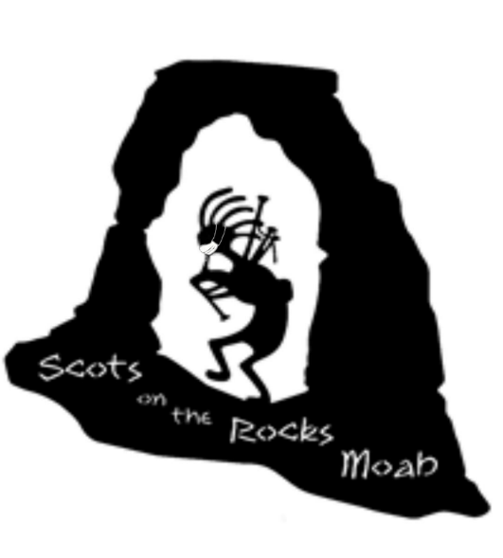
Greetings Clans!
We hope you were at our 2025 Festival and if you weren’t, WOW did you miss a good one! After cancelling our Festival in 2024, we were very apprehensive about trying again in 2025, but we are pleased to report that it was a smashing success! The Moab Celtic Festival in 2026 will be even better with your Clan in attendance!
We would like to official invite you and your Clan to participate in the Moab Celtic Festival brought to you by “Scots on the Rocks” to be held OCTOBER 16-18, 2026 at the Center Street Ball Fields in beautiful downtown Moab! See attached Clan Registration form. Please help by spreading the word!
As you know, Moab is busy every weekend, with multiple events scheduled so we suggest you reserve your lodging as early as possible. The busier the motels get, the higher the price goes, so get your reservations as soon as possible. We will be posting special motel rates as soon as we can. There are several RV parks in the area. There will be NO CAMPING on the festival grounds.
When you arrive, please check in with the Clan Relations table/INFO booth at the Center Street Ball Fields at 250 E Center. You will be given your packet with more information and wrist bands. You must have your wristband on to enter the Park on Friday evening, Saturday and Sunday. We have provided two wristbands for you and your representative. If you need more, please let us know.
You can set up on Friday, October 15th, between 8:00 am and 3:00 pm. You will be able to enter the park on the west side to unload your vehicle. Please be sure to move your vehicle off the field before 3 pm, as we will lock the gates.
The PARADE will be Saturday. We will meet by 100 South Main, on the East side of main street. The parade will proceed to the Ball Fields and enter at the West gate. Please keep an eye on our website www.scotsontherocksmoab.org and our facebook page, Moab Celtic Festival for more updates.
There will be security on the field overnight. Please secure your tent for the night. There will not be electricity to the Clan Tents. Please have your tent ready by 9:00 am on Saturday and Sunday and remain open until 5:00 pm.
Again, we look forward to seeing you and your clan! We want this Fest to be as awesome as it can be, so if you have any suggestions for us, please share!

Dan and Marta Lamont, Clan Relations
435-210-0080 and 435-260-2456

