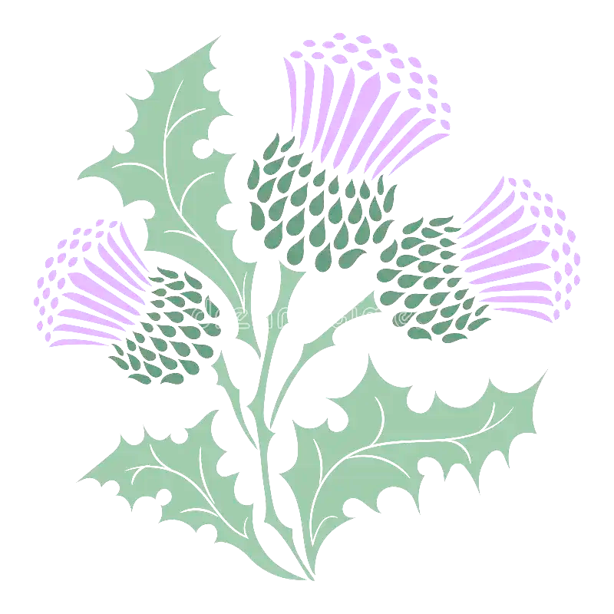

It is with great sadness that we have decided to cancel the Moab Celtic festival for 2024. Please understand that this decision was not made lightly. However, we feel that is the best option. The truth is that we are unsure if we would be able to hold a festival that was up to our usual standards. We would hate to hold a lackluster festival just for the sake of holding one. Our fans and supporters deserve better.

The reasons are largely financial, as we are sure you are also feeling the strain of inflation. Our attendance was down last year and we believe it was due to the unstable economy. There are several costs involved with holding a festival, and the money was just not there this year. Due to increasing travel costs our vendors have reported difficulties traveling from festival to festival without having a guaranteed turnout to recoup their expenses.

Sponsorships and donations are a huge part of putting on a festival and we could greatly appreciate our amazing sponsors that have made the festival possible for the past 10 years! We know that the community in Moab looks forward to this festival every year and we will be back bigger and better than ever in 2025! There is more to come, but for now we appreciate your continued support and look forward to seeing all of you again soon! Thank you!