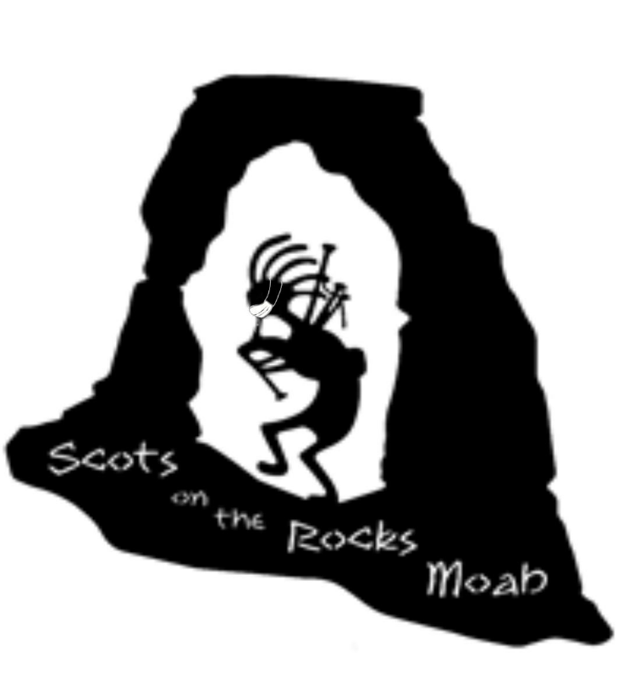
Greetings Clans!
We are writing to invite you to the 10th Annual Moab Celtic Festival brought to you by “Scots on the Rocks” to be held OCTOBER 20-22, 2023 at the Center Street Ball Fields in beautiful downtown Moab! See attached Clan Registration form.
As you know, Moab is busy every weekend, with multiple events scheduled so we suggest you reserve your lodging as early as possible. The busier the motels get, the higher the price goes, so get your reservations as soon as possible. We will be posting special motel rates as soon as we can. There are several RV parks in the area. There will be NO CAMPING on the festival grounds.
When you arrive, please check in with the Clan Relations table/INFO booth at the Center Street Ball Fields at 250 E Center. You will be given your packet with more information and wrist bands. You must have your wristband on to enter the Park on Friday evening, Saturday and Sunday. We have provided two wristbands for you and your representative. If you need more, please let us know.
You can set up on Friday, October 20th, between 8:00 am and 3:00 pm. You will be able to enter the park on the west side to unload your vehicle. Please be sure to move your vehicle off the field before 3 pm, as we will lock the gates. We hope to have the Strong Man Competition this year!
We are also planning a PARADE from the Visitor’s Center to the Ball Fields on Saturday morning. Please keep an eye on our website www.scotsontherocksmoab.org and our facebook page Moab Celtic Festival for more updates.
There will be security on the field overnight. Please secure your tent for the night. There will not be electricity to the Clan Tents. Please have your tent ready by 9:00 am on Saturday and Sunday and remain open until 5:00 pm.
Again, we look forward to seeing you and your clan! We want this Fest to be as awesome as it can be, so if you have any suggestions for us, please share!

Dan and Marta Lamont, Clan Relations
435-210-0080 and 435-260-2456

