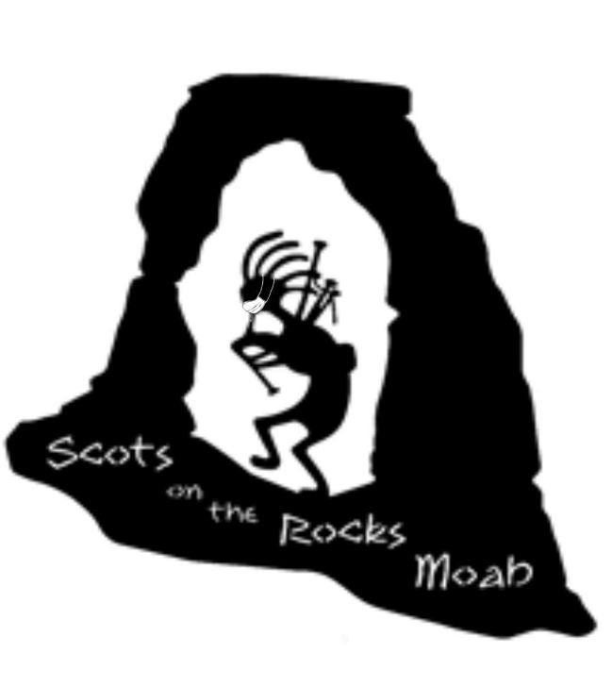
Moab Celtic Festival
“Scots on the Rocks”
October 20,21&22 2023
Clan Registration Form

Your Clan is invited to participate in the 10th Annual Moab Celtic Festival & Highland Games to be held on
October 20, 21, &22, 2023 at the Center Street Ball Field at 250 E Center, Moab, UT 84532.

Clan Name/Organization: ___________________________________________________________

Representative name: _______________________________________________________________

Address: _________________________________ City: ______________________________ State: _________ Zip: ________

Phone: ________________________________ E-mail: ______________________________________

Alternate Representative: __________________________________________________________

Alternate’s phone # and E-mail: ____________________________________________________

Spaces will be assigned on a first come, first served basis. The Clan Relations Committee reserves the right to make final placement of clans. This form MUST be postmarked no later than October 1, 2023.

Regular space 10’ x 10’ $40 _________________
Double space 20’ x 10’ $65__________________
Please specify _____ 10’ frontage or _____20’ frontage
Tables $10.00 each ___________
Chairs $ 2.00 each ___________

Total:___________
Send to: Scots on the Rocks, PO Box 456, 3331 Roberts Drive, Moab, UT 84532
Please make checks payable to: Scots on the Rocks Moab
YOU ARE PERMITTED TO SELL ONLY YOUR CLAN RELATED ITEMS.

NO RAINCHECKS, NO REFUNDS.

In consideration of the acceptance of this entry, I hereby for myself, my heirs, executors and administrators, waive and release the Moab Celtic Festival/Scots on the Rocks or its Games Committee, agents, representatives and assignees, for any and all injuries suffered by me or any clan member in attendance. The Moab Celtic Festival/Scots on the Rocks retains all rights to video, audio and photo images.

______________________________
Signature of Clan Representative
Entry void if not signed

